MS Active Directory

Extracted from [here](https://www.youtube.com/watch?v=85-bp7XxWDQ&list=WL&index=30):

MS active directory is an identity platform. AD is part of Directory Services. Directory Service is simply a database of objects (users, computers, stuff etc). All are distributed in basis of organizational units.

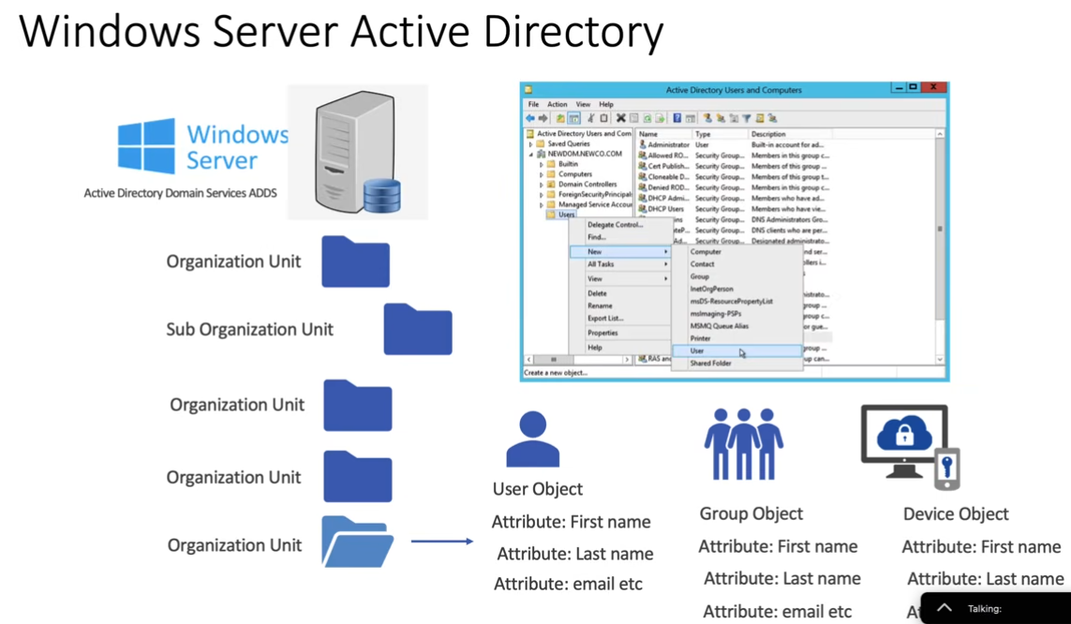

Example:

DC1 contains a master copy of account`s directory so we don’t store AD DB on DC1 but can make it replicate the AD DB for reasons like (disaster recovery, performance reasons, load balancers). In example there are 2 offices both have different servers (Domain Controllers) that are installed with active directory and are replicating copies of master DB.

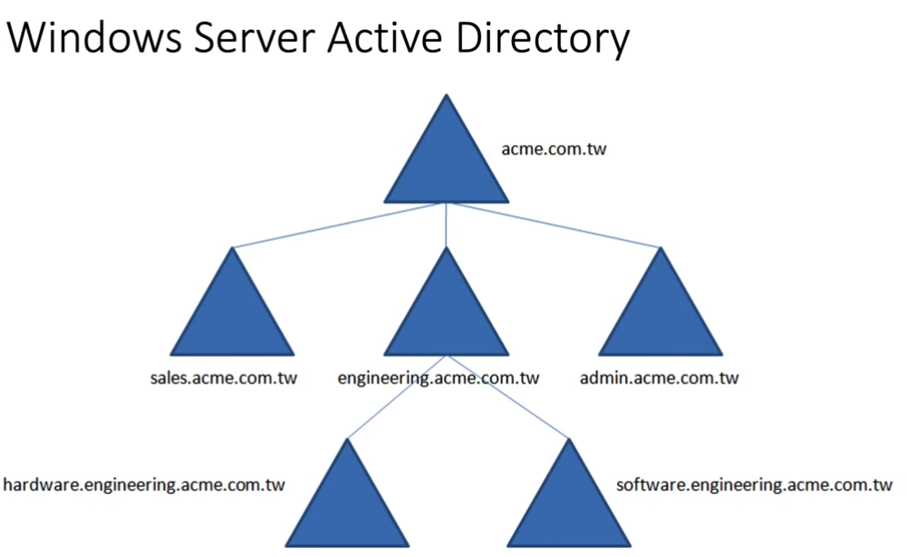

Now we install DB on azure active directory instead of windows one.

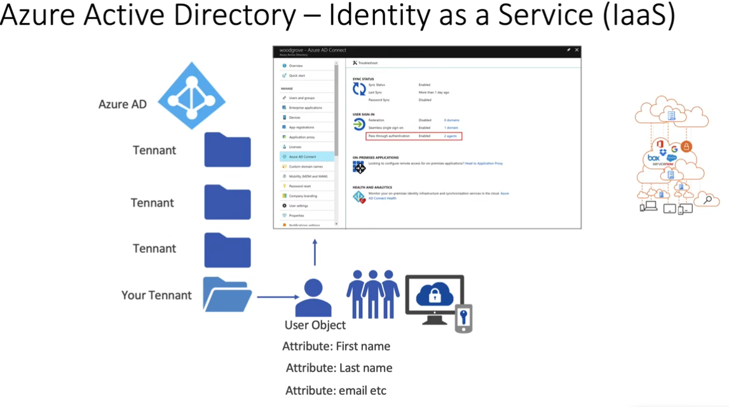

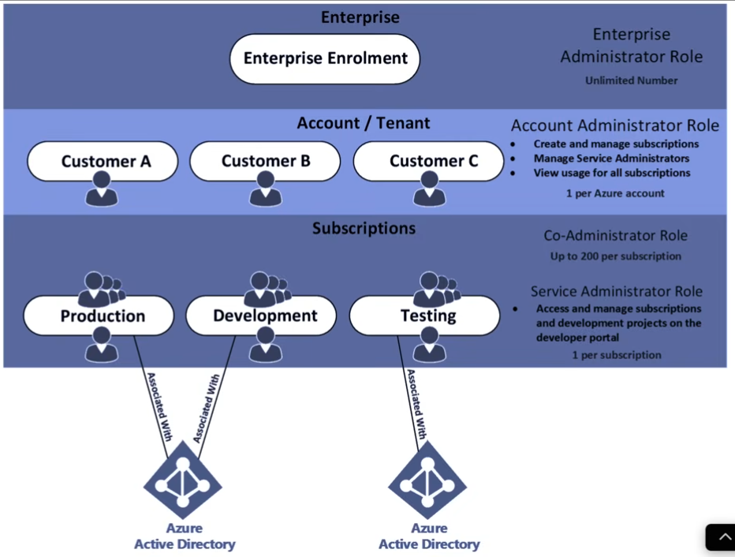

Windows Domain

Extracted from [here](https://www.youtube.com/watch?v=cTe5GsyhKUk&list=WL&index=34)

Windows domain is just a bunch of computer networks with windows.

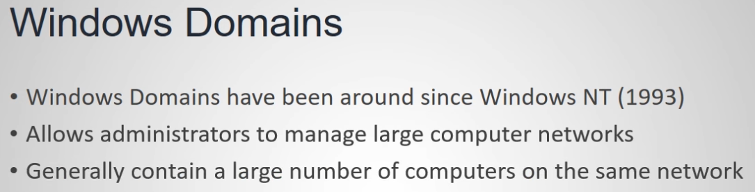

AD DS stands for Active Directory Domain Services. 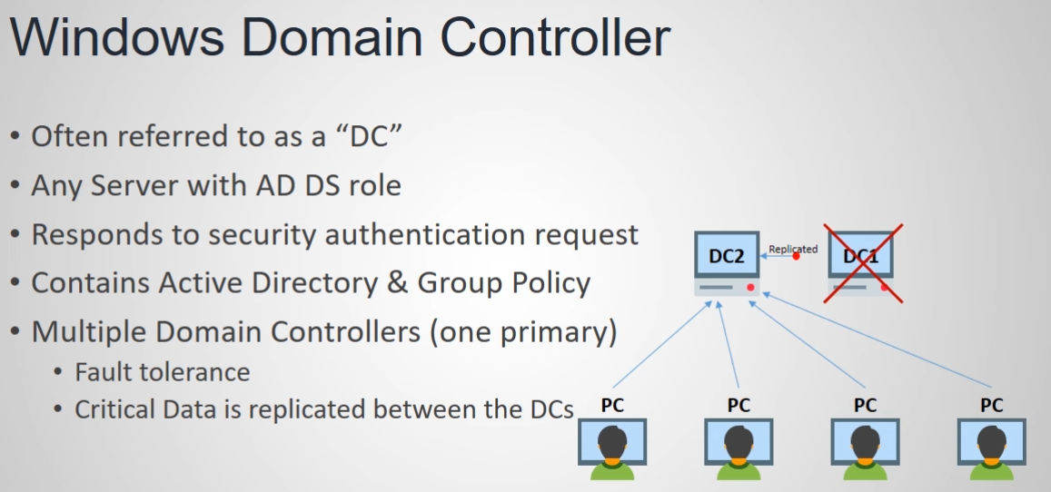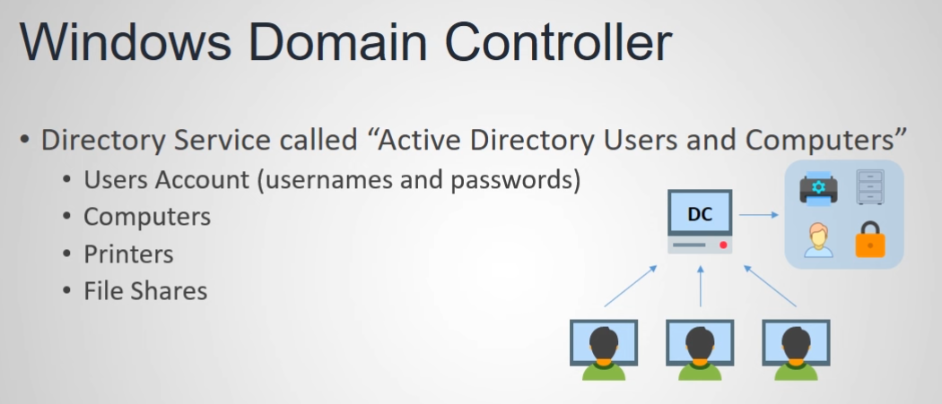

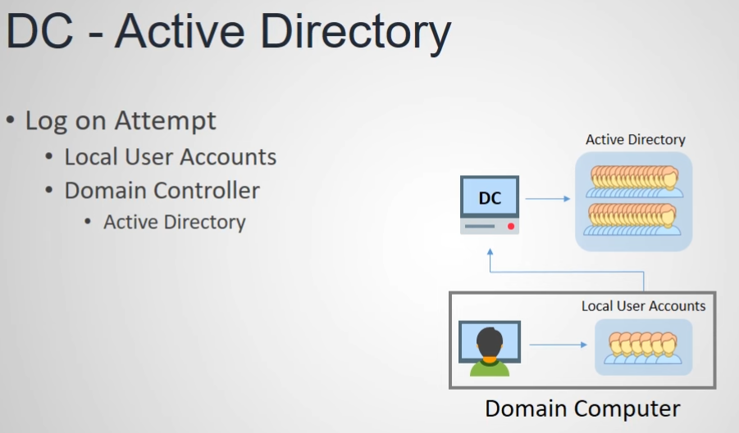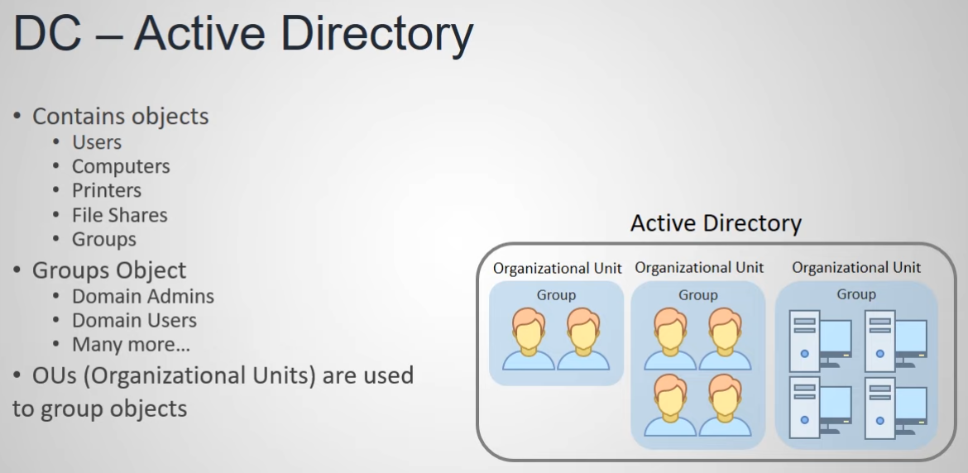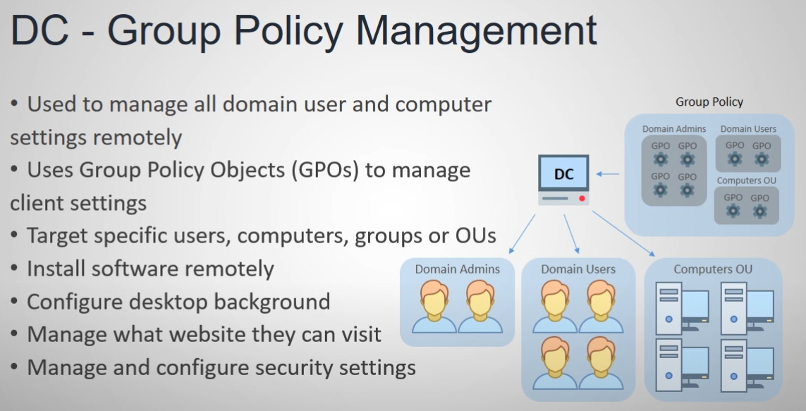

Information stored in active directory is known as AD objects. AD tree corresponds to domain child domains and root domain this topic is known as AD hierarchy.